DATA REPORT ANALYST BY REGINA BEE BECARI

INTRODUCTION

In this documentation, I present a comprehensive analysis of pertinent data trends in Office World. Dive into key insights that serve as a foundation for informed decision-making and strategic actions.

COMPANY BACKGROUND

Office World is a company specializing in leading Stationery and office supplies dealers in New Castle for the whole UK for over 60 years.
Company objectives
They would like to offer more in-demand products to their customers. They would like to better understand the popularity and profitability of their products as well as their current customer base to improve their marketing efforts and reach more customers with the right products.

EXECUTIVE SUMMARY

The problem.
They lack understanding of their market capabilities since they don’t know which products are the most sold and which ones are the most profitable.

The analysis's goal.
Find which products are the most profitable and sold, which customer segments are more prominent, and if they could increase the revenue by targeting the correct product and audience.

The data and techniques employed.
Excel sheets were given by the employer. The technical tools used for this analysis were Excel (Pivot Table, Formulas.) and Power BI.

Brief interpretation of results.
The results indicate two most sold and profitable products could help target the audience (customer segment) through marketing campaigns but there is no correlation between the discounts offered and the sales.
These findings suggest weak marketing campaign studies, highlighting poor market research methods. This interpretation underscores the importance of key performance indicators and serves as a foundation for stronger campaign tactics.

MAIN BODY
Summary of errors in data:
Data identification
The Data to clean today will be named; Office World Supplies Sales Data, a copy will be used instead of the original.
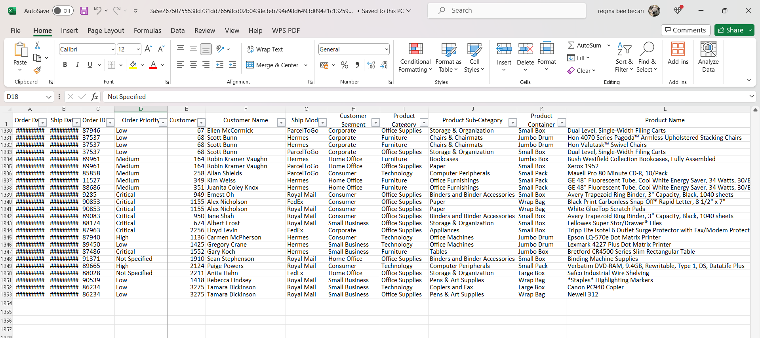
Now, the copy must be renamed Office World Supplies Sales Data Final Project By Regina Bee Becari
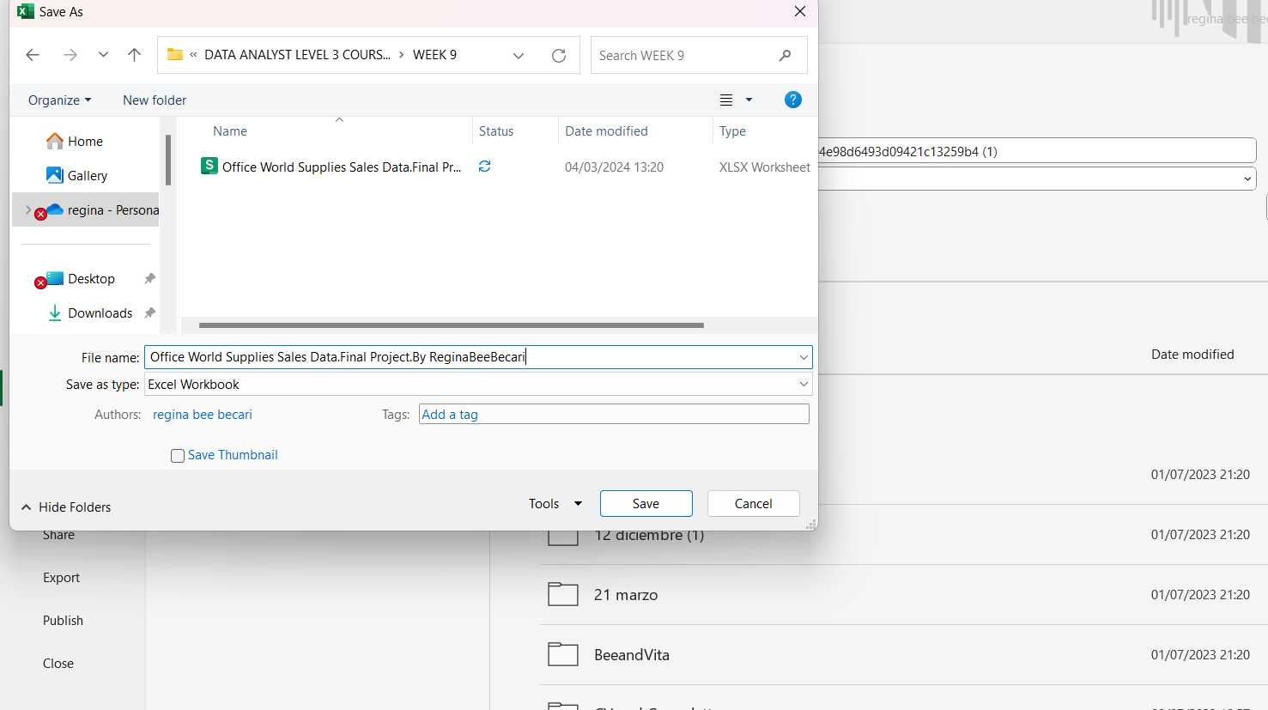
This document is composed of 4 sheets, the first sheet is named “orders”, the second one is “returns”, the third is “users” and the fourth is “objectives”.
The data needed is located between the first sheet and the third one, the fourth sheet explains the requirements the company has for this exercise and will be looked at in detail in the next parts of the document.
After reading the Data given, some errors were found on it.
The errors found will be listed below:
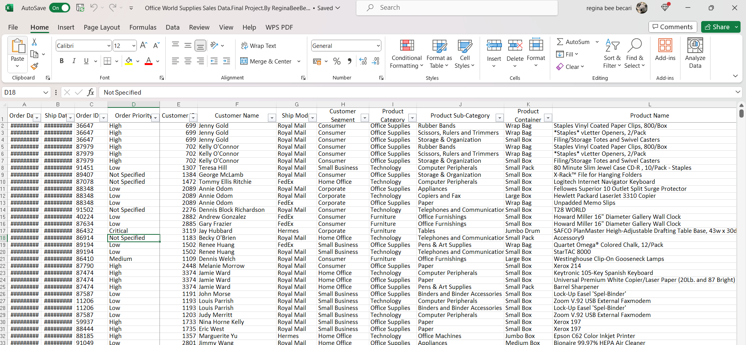
Over compressed columns, unable to read the Data.

No difference between column names and the rest of the Data

Poor distribution between Columns; poor organization making reading difficult, Data must be clear and ready to be read to help the understating of the values.

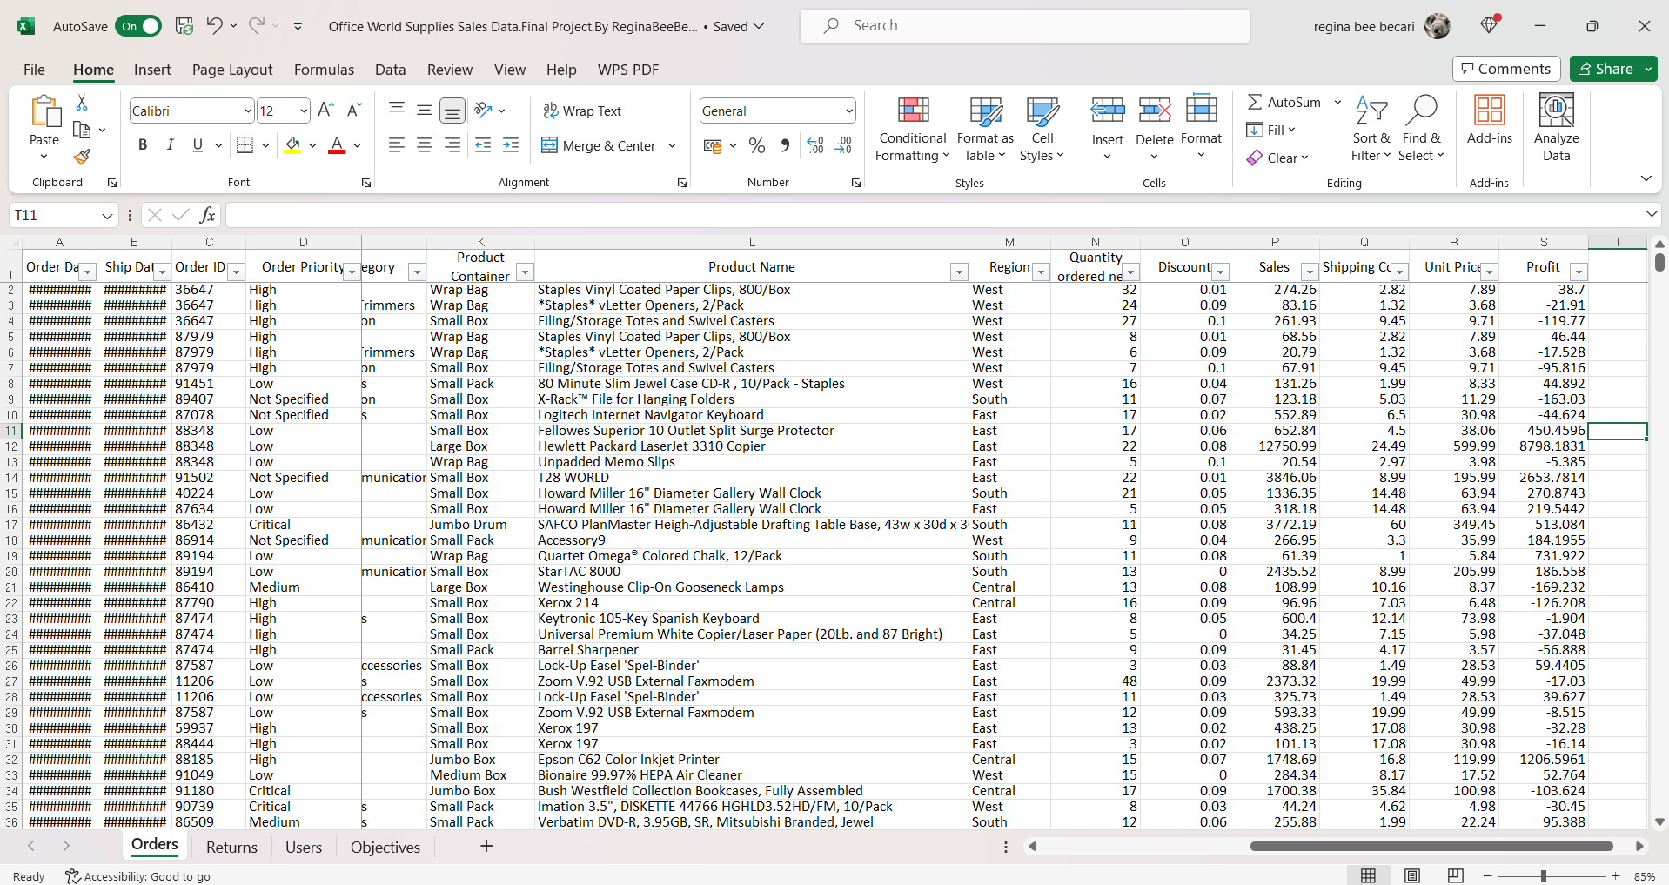
Columns with numbers need similar guidance with decimals for example: the values of 0.1 and 0 in column O are wrongly written several times, in a column where numbers usually have two decimals.
Missing currency values

After detecting the errors, they must be corrected to obtain clearer Data to be used:

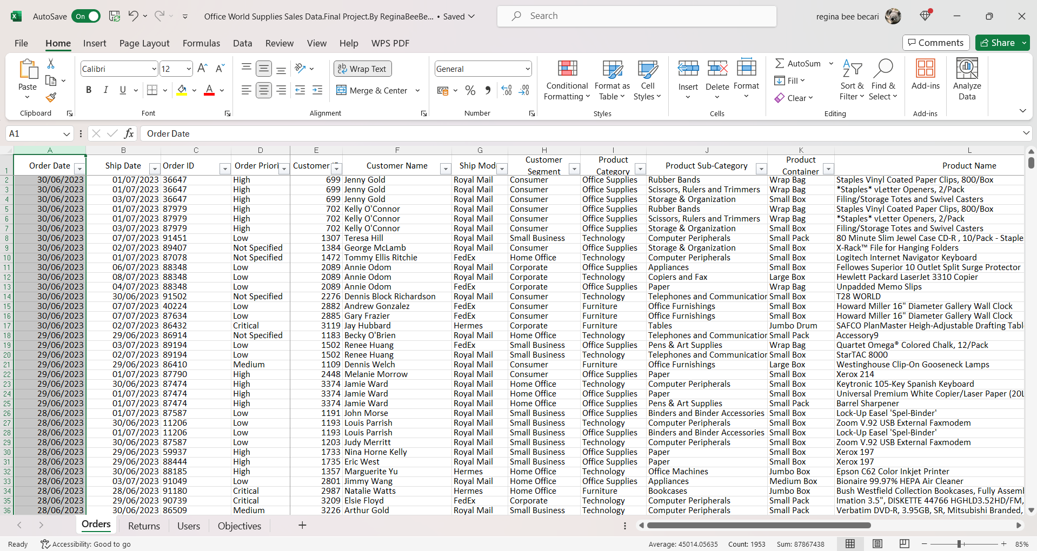
Decompress Columns ‘A’ and ‘B’ to read their values content.

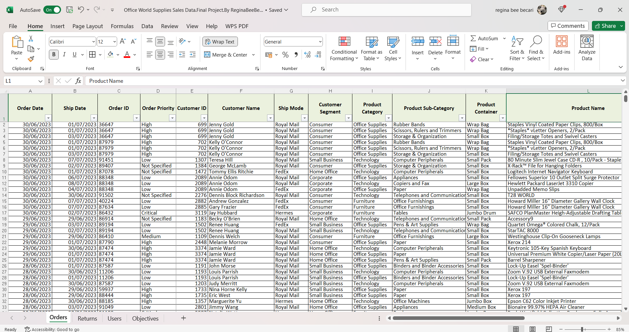

Column names have been painted, bolded, and reshaped also borders have been added for better organization of the data.
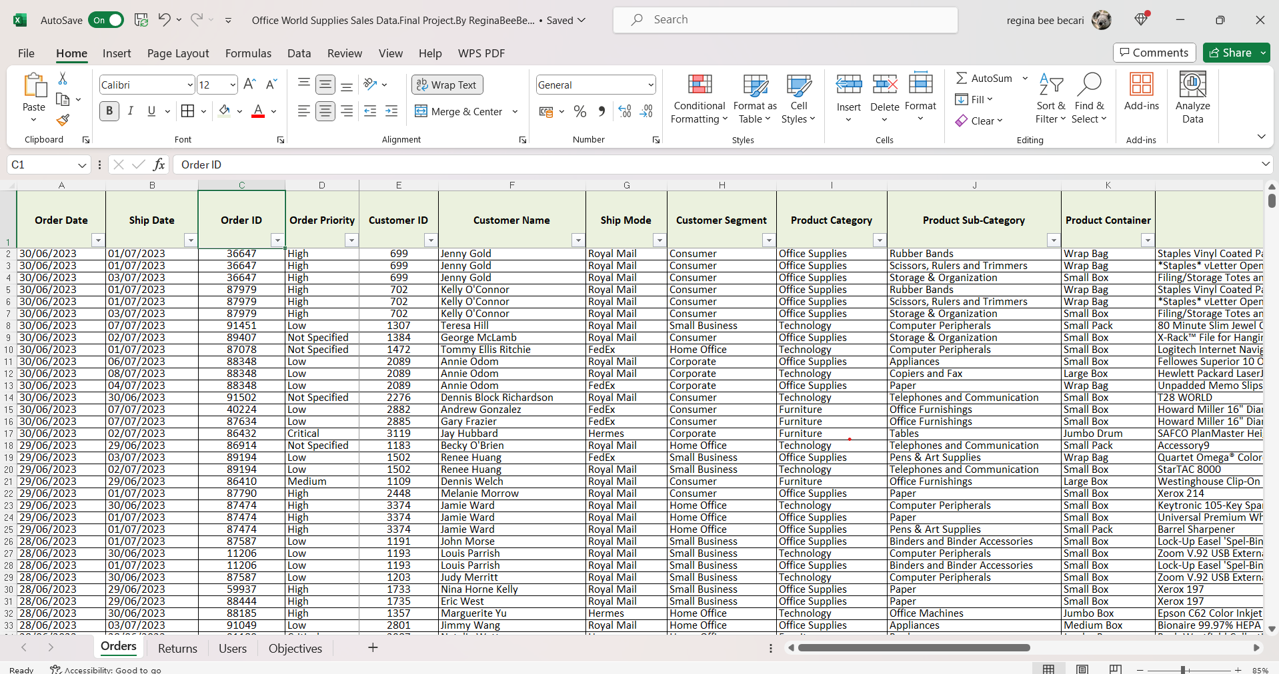

Columns have been reshaped and organized centralizing some values for better reading, and making son column names bigger.

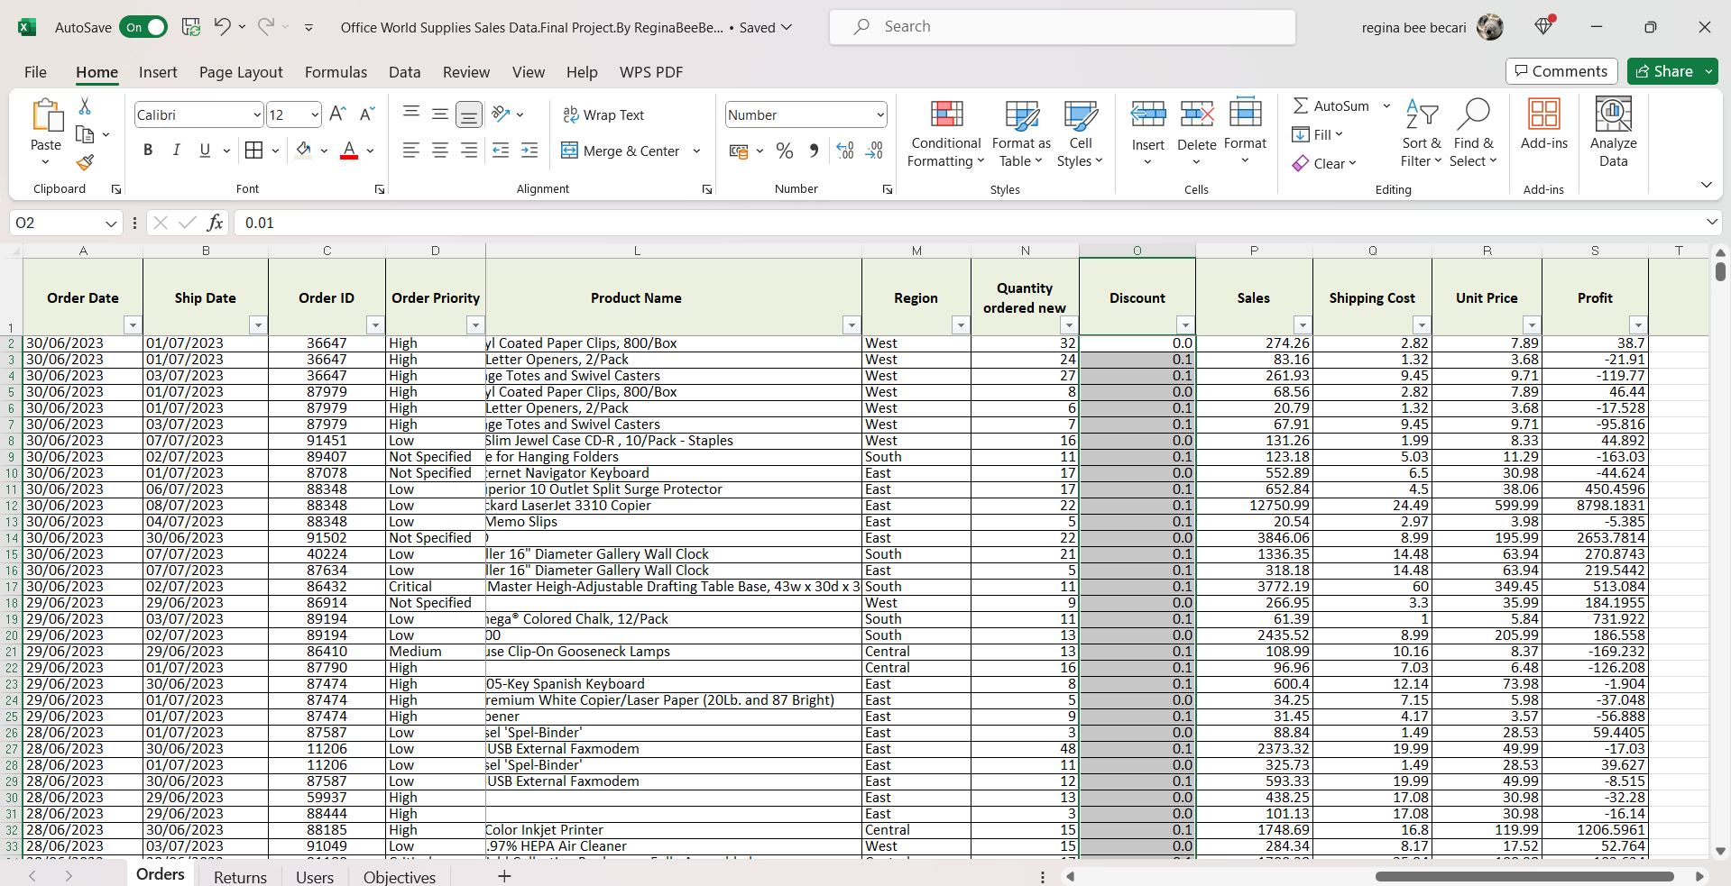
Round up column O values to one decimal using the roundup tool below the number section on the home page of Excel.
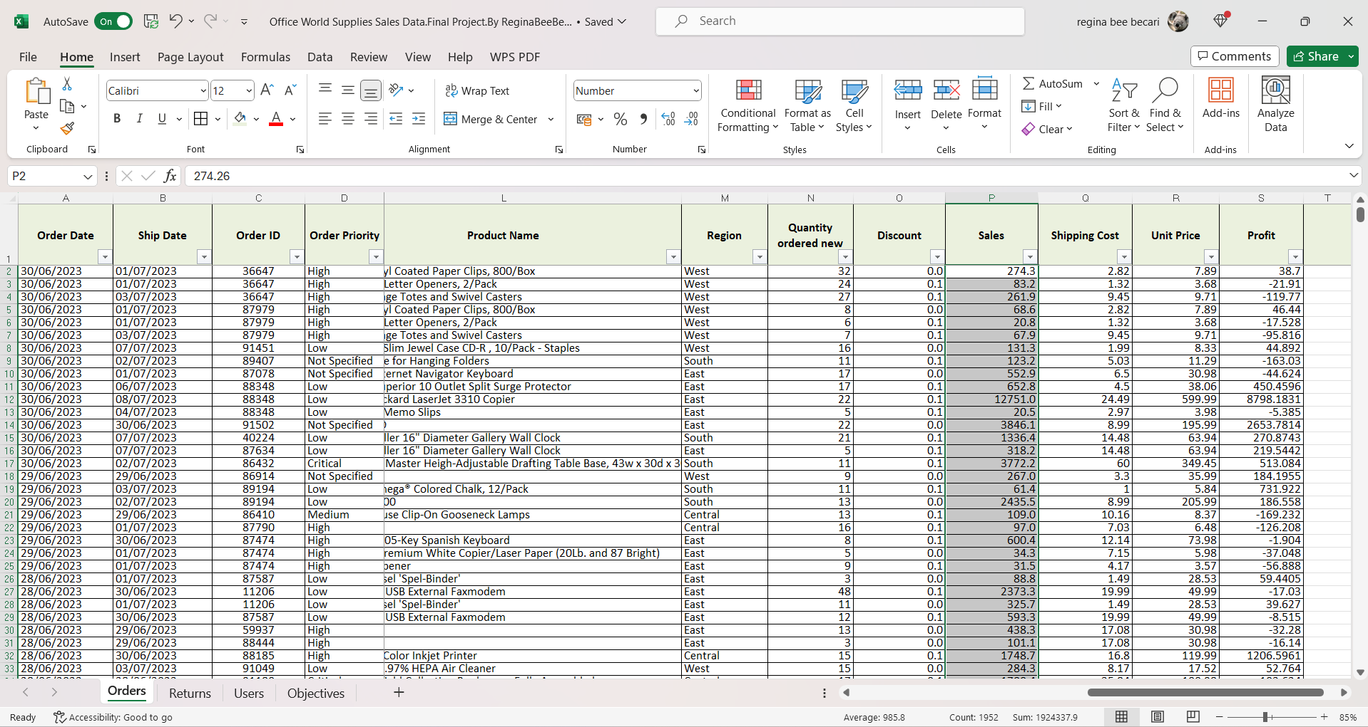

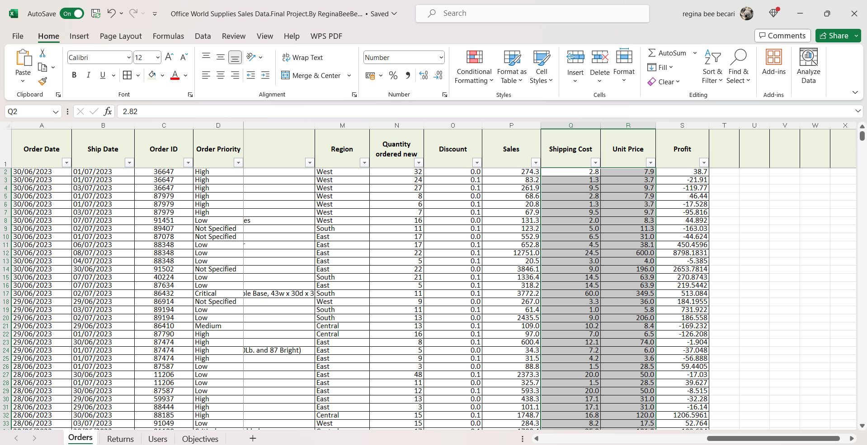

Round up columns, “P, Q, and R” values to one decimal using the roundup tool below the number section on the “home page” on Excel again.
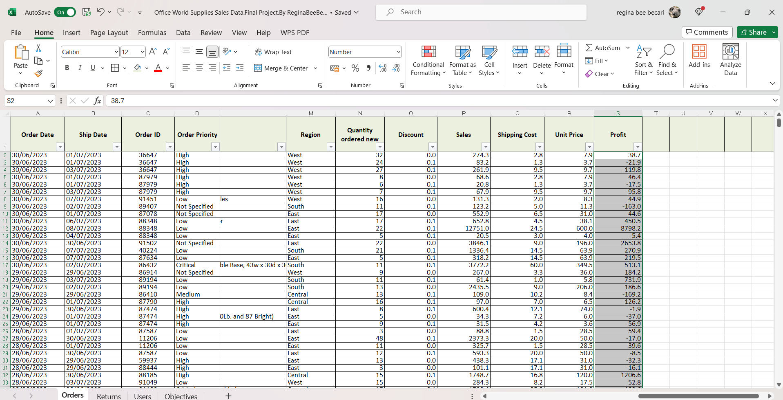

Round up column S values to one decimal using the roundup tool below the number section on the home page of Excel.
Another option to round up decimals is using the formula ROUND (S1:S1953, 1)

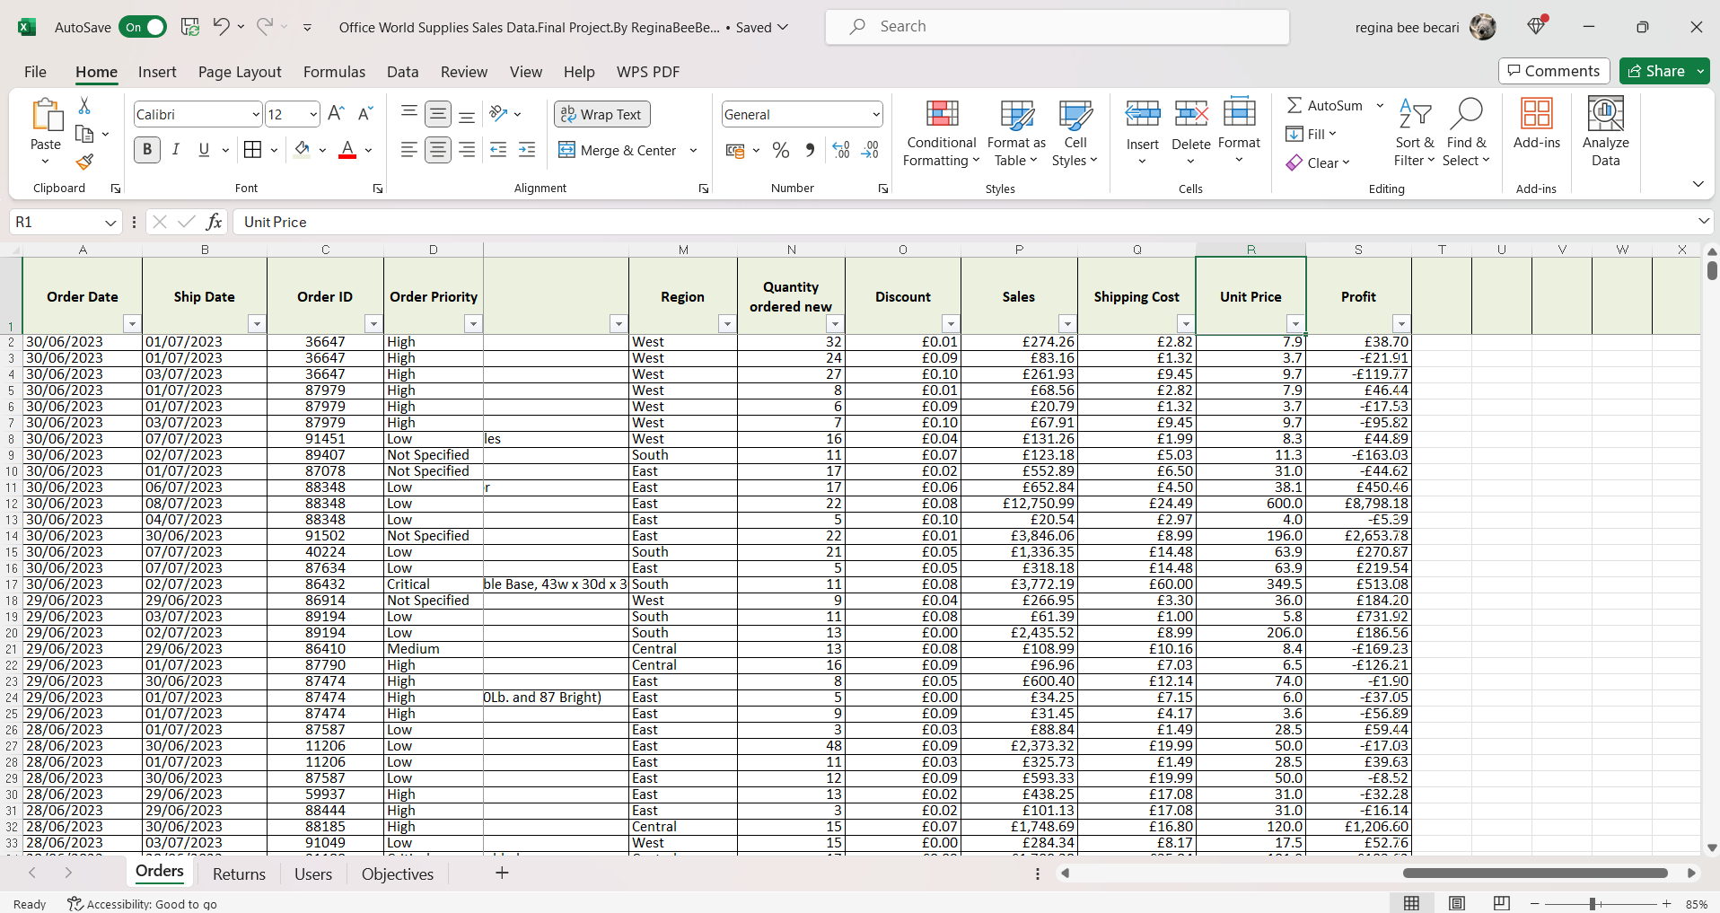

Add currency (GB) Values to the columns “O, P, Q, and S”.

Details on how the analysis process was compliant with regulations and laws.
Adherence to DPA in handling the data fairly and transparently:
Handling data fairly and transparently, aligning with the ethical principles reflected in the regulatory landscape. My commitment extends to safeguarding personal and sensitive data and implementing robust measures to guarantee the utmost protection.

Applying techniques such as encryption for data in transit and storage, thereby fortifying the security infrastructure. Access control mechanisms and stringent authentication protocols are integral to our strategy, ensuring that only authorized personnel can access personal and sensitive information. Additionally, we emphasize the principles of data minimization, limiting the collection of data to what is strictly necessary for predefined purposes.

Hypothesis
In this section, I will analyze the data to find answers to our questions.
- What customer segments have the highest sales?
- What is the number of total sales? Are the sales increasing during the 6 months?
- What is the most popular Product? Which are the lowest 3 sold products? Can we increase their sales? (remove irrelevant not correlation)
- Is there a correlation between sales and discounts? (if yes target those areas (small business sectors and regions)
- Could we increase our sales target by 20,000,000 £ for the next 6 months using the 2 most profitable products? (Yes / No) and where we must improve if we do so.

Findings of analysis (summaries, calculations, pivot tables, charts, etc) and Written insights explaining the outcome/results of each analysis and response to the hypothesis

- What customer segments have the highest sales?

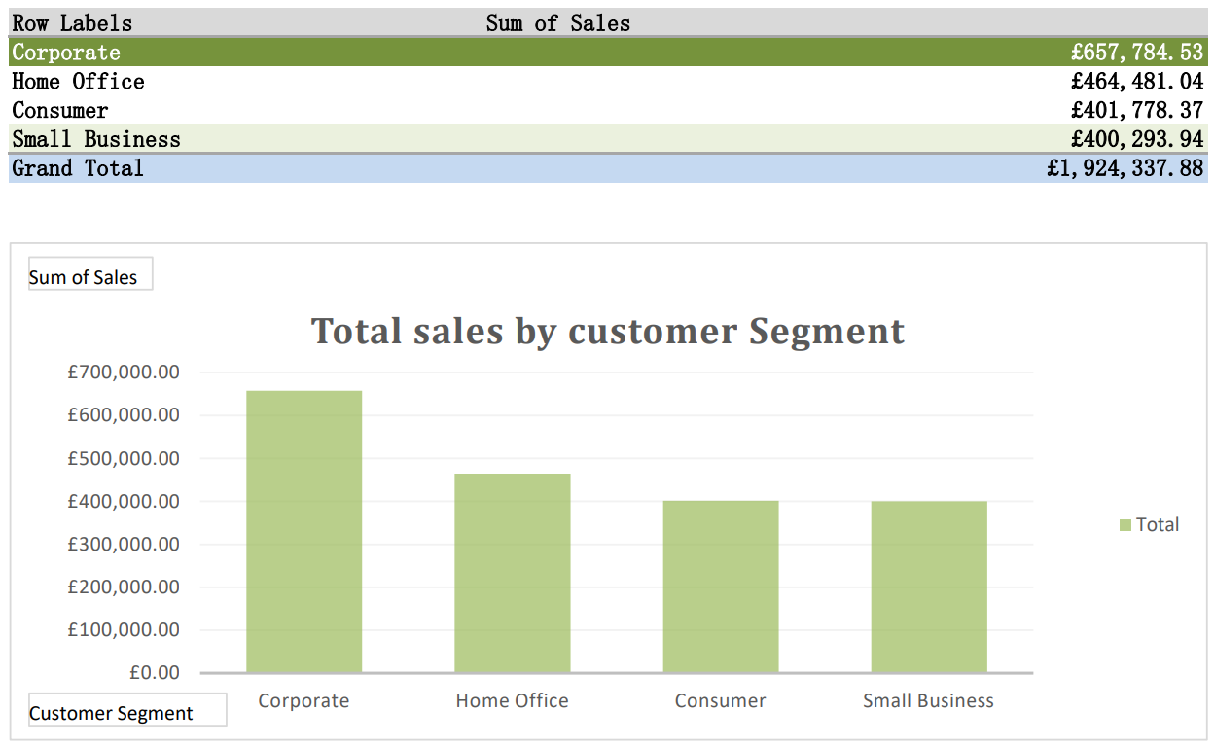
The highest is the corporate segment with 657,784.53£ sales and the lowest is the Small Business segment with 400,293£ sales.

Study of the region and the total sales for 6 months.

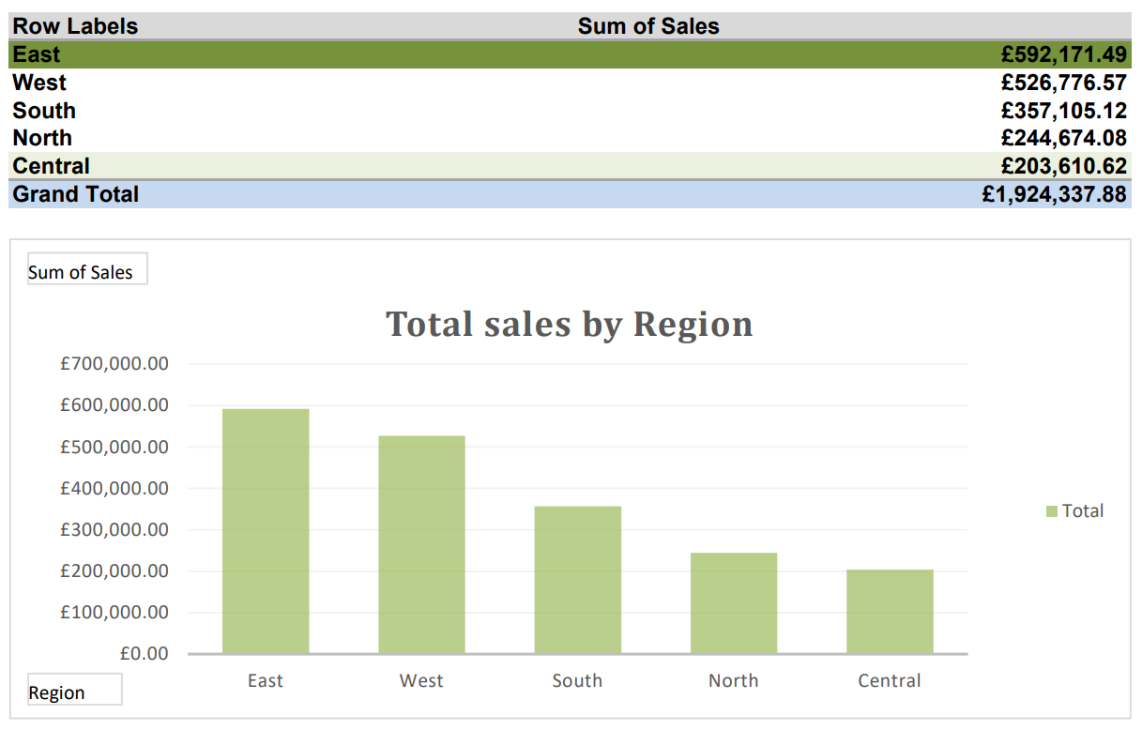
The highest is East Region with 592,171.49£ sales and the lowest is Central Region with 203,610.62£ sales.

Study of the customer segments and the total new orders for 6 months. To see who is actively ordering.
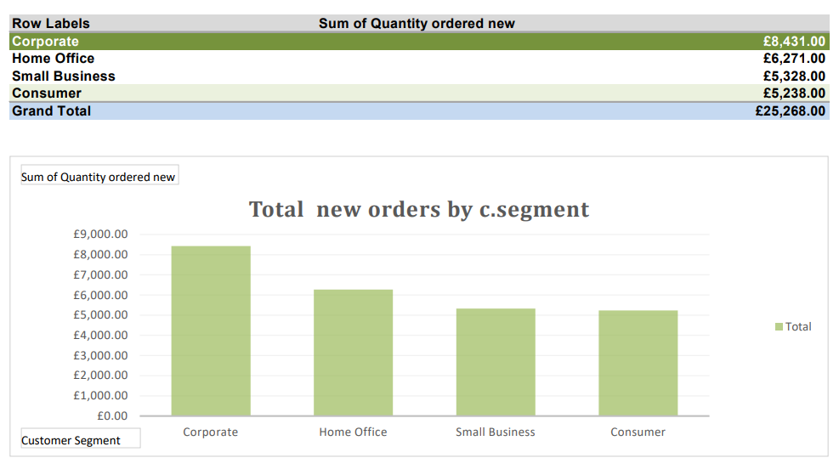

The highest is the Corporate segment with 8,431 £ in new orders and the lowest are Consumers segment with 5,238 £ in new orders.

Study of the regions and the total new orders for 6 months.
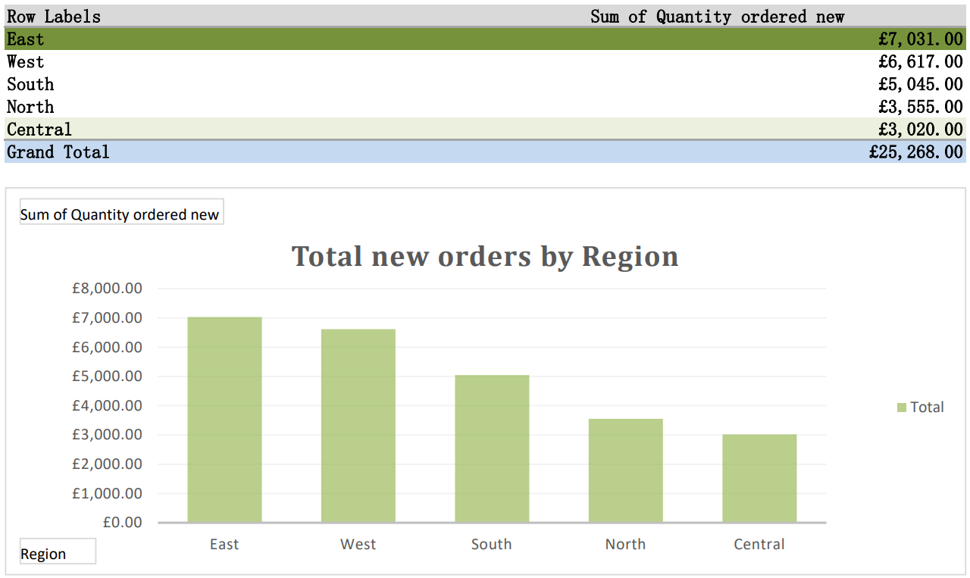

The highest is the East region with 7,031 £ in new orders and the lowest are Central region with 3020 £ in new orders.

2. What is the number of total sales? Are the sales increasing during the 6 months?
Total sales per month
Jan | £274,766.92
Feb | £326,101.47
Mar | £271,696.67
Apr | £389,831.95
May | £306,572.07
Jun | £355,368.80
Grand Total | £1,924,337.88

Total sales during the 6 months are 1,924,337.88£.
2.1 Are the sales increasing during the 6 months?
Lowest sales
Highest sales
 | Total sales per month
Jan | £274,766.92
Feb | £326,101.47
Mar | £271,696.67
Apr | £389,831.95
May | £306,572.07
Jun | £355,368.80
Grand Total | £1,924,337.88

First month/last month comparison
Jan | £274,766.92
Jun | £355,368.80
Sales differences | £80,601.88

Highest sales per month
Apr | £389,831.95

Sales increased = 80,601.88£ during this period of 6 months.

This can be also appreciated in a scatter graph:
Jan Feb Mar Apr May Jun

3. What is the most popular Product?
TOP 5 SOLD /Product Name | Total sales
Polycom ViewStation™ ISDN Videoconferencing Unit | £46,538.69
Okidata ML395C Color Dot Matrix Printer | £47,611.09
Global Troy™ Executive Leather Low-Back Tilter | £50,871.21
Lexmark 4227 Plus Dot Matrix Printer | £61,071.73
Fellowes PB500 Electric Punch Plastic Comb Binding Machine with Manual Bind | £69,013.48

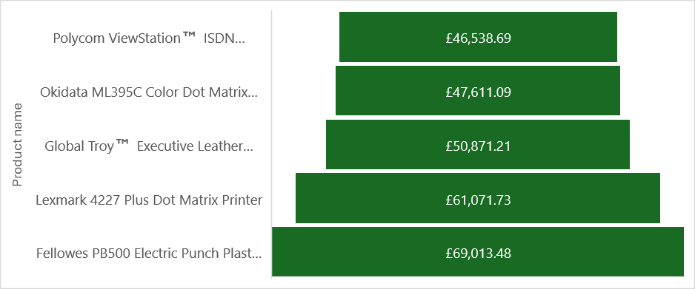
Which are the lowest 3 sold products?
Product name | Total Sales
*Staples* Packaging Labels | £3.07
Letter Slitter | £3.13
Avery Reinforcements for Hole-Punch Pages | £3.53

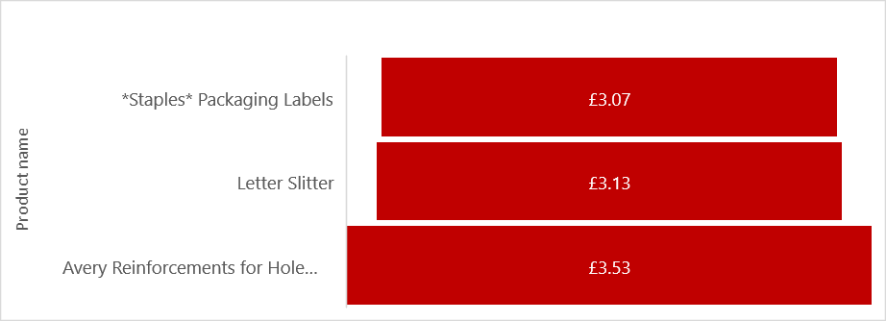
- Is there a correlation between sales and discounts?

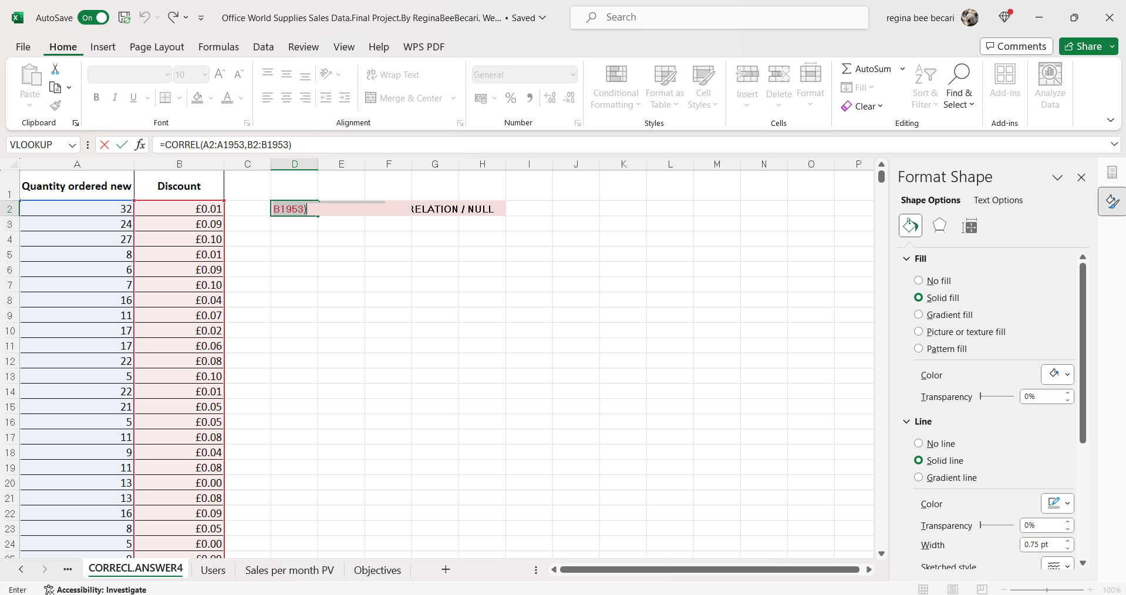

-0.0094 |  | NO CORRELATION / NULL

We can't target any campaign based on the data received for the 6 months since there isn’t a correlation.

- Could we increase our sales target by 20,000,000 £ for the next 6 months using the 2 most profitable products? (Yes / No) and where we must improve if we do so.

Even though these are the most sold products I could see that some of them are giving negative profit, so the first thing is to reduce to two the list of most sold and profitable products.

Most Profitable Products | Total Sales | Total Profit
Fellowes PB500 Electric Punch Plastic Comb Binding Machine with Manual Bind | £69,013.48 | £23,865.90
Global Troy™ Executive Leather Low-Back Tilter | £50,871.21 | £18,628.15

Product name/Customer segment | Total Sales | Total Profit
Fellowes PB500 Electric Punch Plastic Comb Binding Machine with Manual Bind | £69,013.48 | £23,865.90
Small Business | £66,424.47 | £23,502.35
Consumer | £2,589.01 | £363.55
Profit
Sales

Product name/Customer segment | Total Sales | Total Profit
Global Troy™ Executive Leather Low-Back Tilter | £50,871.21 | £18,628.15
Consumer | £37,148.16 | £9,159.24
Corporate | £7,360.20 | £5,078.54
Home Office | £6,362.85 | £4,390.37

Sales
Profit

Could we increase our sales target by 20,000,000 £ for the next 6 months using the 2 most profitable products?

The answer is, no with the current forecasting the company has, they will need to work into new campaign strategies using these products and target better their audience to understand their needs.

Another important detail *

Product Name/Order Priority | Total Sales
Fellowes PB500 Electric Punch Plastic Comb Binding Machine with Manual Bind | £69,013.48
Low | £9,252.81
Not Specified | £59,760.67
Global Troy™ Executive Leather Low-Back Tilter | £50,871.21
Critical | £37,148.16
High | £7,360.20
Not Specified | £6,362.85

The company will need deeper research into the order priority of those two products since the data reflects that Fellowes PB500 Electric Punch Plastic Comb Binding Machine with Manual Bind has the highest sales that are “Not specified” Meanwhile Global Troy™ Executive Leather Low-Back Tilter is required in a critical priority.

CONCLUSION

According to the data given, the customer segment that shows higher affinity to our entire catalog of products comes from the corporate segment, followed by the home office, small businesses, and consumers having better affinity in the East and West regions than the Central and North regions.
So, I could say the corporate segment located in the East region has the highest affinity to our products, considering this, I would focus on this customer segment, creating further analysis in this particular area and audience to find out how to increase the relationship with them.
The amount of sales does not correlate with the discounts offered for the moment, therefore I wouldn’t suggest a quick investment in the campaign without the target audience as I explained before.

The most popular Product is the Fellowes PB500 Electric Punch Plastic Comb Binding Machine with Manual Bind with a total sales of 69013.48£
Followed by the Lexmark 4227 Plus Dot Matrix Printer, Global Troy™ Executive Leather Low-Back Tilter, Okidata ML395C Color Dot Matrix Printer, and Polycom ViewStation™ ISDN Videoconferencing Unit.

After more data is collected from the audience target they should consider Creating a discount package on the most profitable products;
The Global Troy™ Executive Leather Low-Back Tilter is a chair that can be sold as a package offering additional services or furniture.
The Fellowes PB500 Electric Punch Plastic Comb Binding Machine with Manual Bind could be sold with kit comb bindings adding these with a discount.
Also, the introduction of club cards could impact in general the sales.

RECOMMENDATIONS

The East region has the highest affinity to our products, considering this, I would focus on this customer segment, creating further analysis in this area and audience to find out how to increase the relationship with them.
After more data is collected from the audience targeted, they should consider Creating a discount package on the most profitable products;
majority of the top five products are for long-term use, so the company could add short-term products to it or extra deals of short-term products during the year, to secure more sales.
Also, the introduction of club cards could impact in general the sales.

